Secret Word Game
Can you work out the secret words by writing the initial sound for each of the picture, put the sounds together to reveal a word! The first one has been done for you.
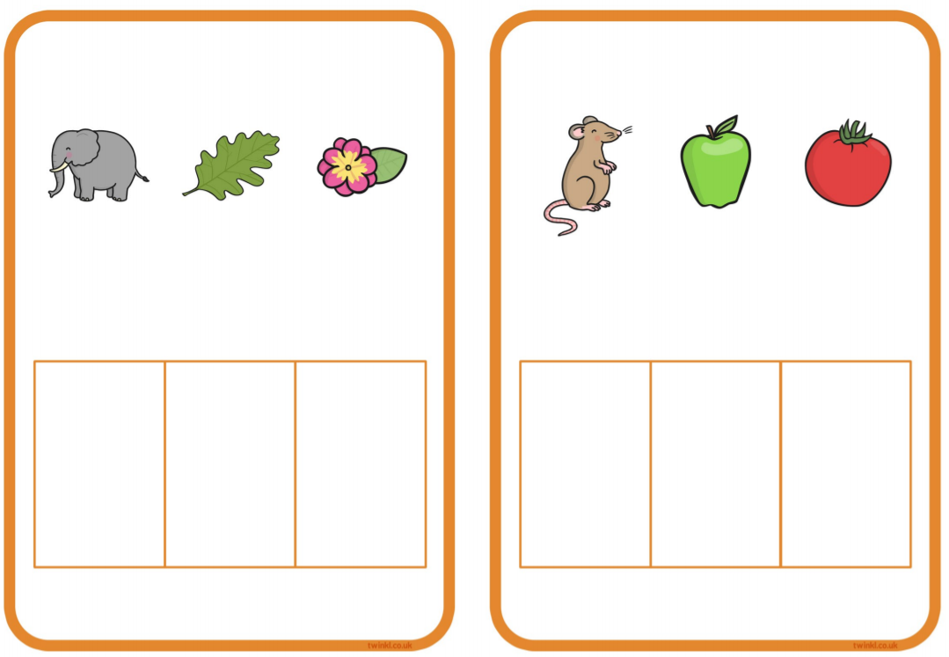
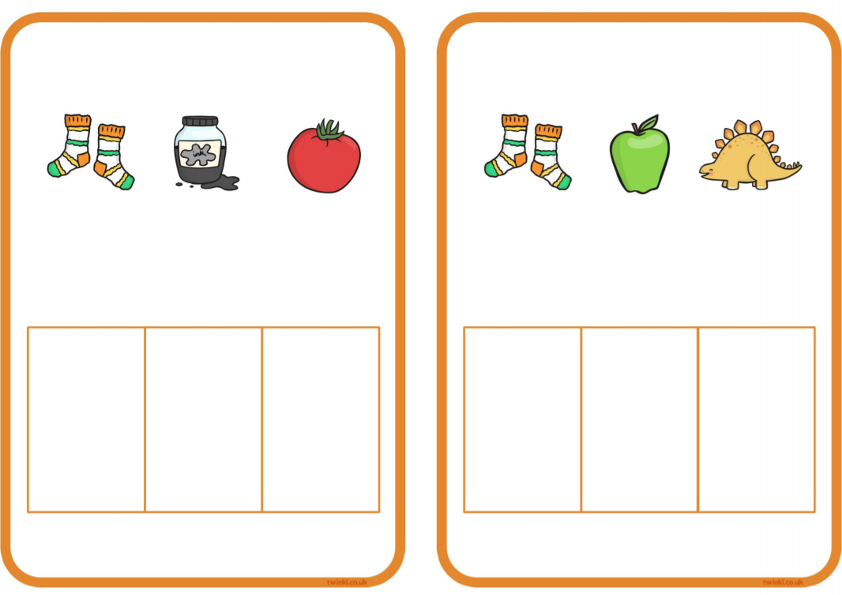
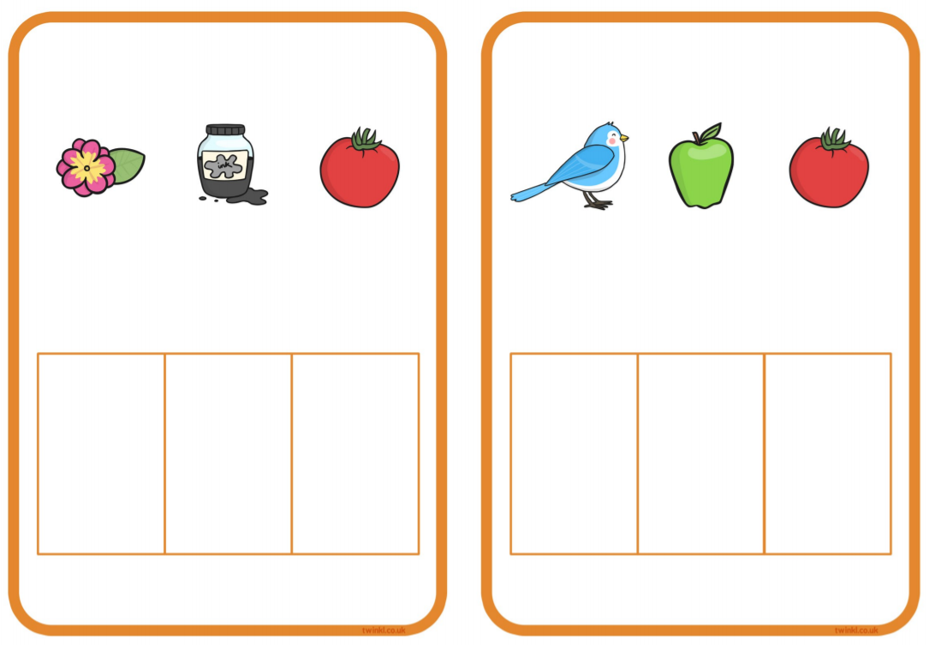
t
i
f

