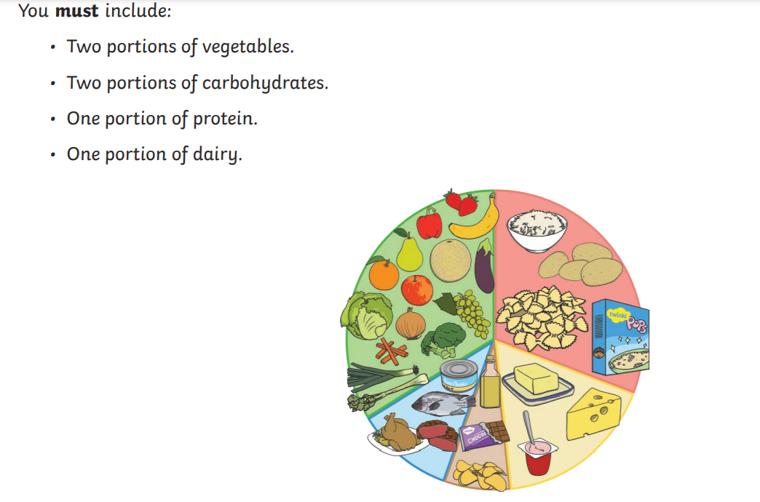
Can you design a healthy meal?

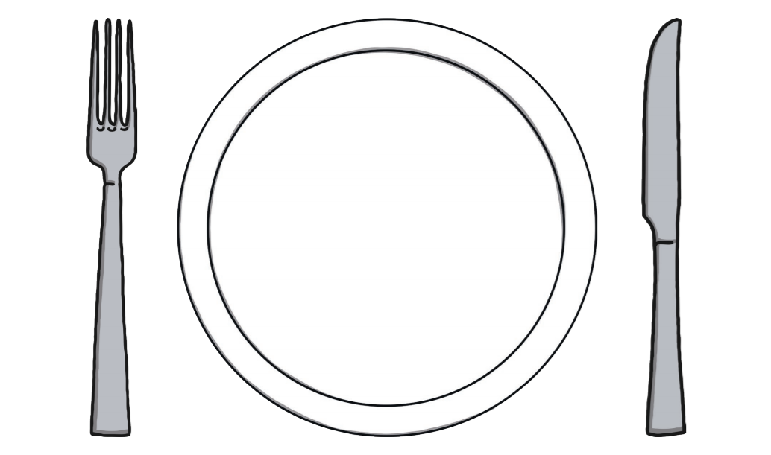
You could draw a circle on a piece of paper as your plate just like this…
Ext- Can you write a sentence about the meal you have designed?

