Kandinsky

In Art we have been looking at an artist called Kandinsky.
We thought about primary and secondary colours – can you remember them?
Today we would like you to create your own Kandinsky pictures.
Miss Jackson has made two examples of how you could do this at home.
Don’t forget to send pictures of your work.

Using objects
Collect a range of items from around your house, make sure you ask an adult!
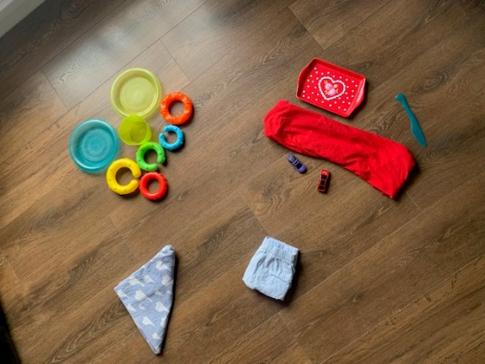
Can you tell how Miss Jackson has sorted hers?

After that, arrange your items like Kandinsky. Here is my example.

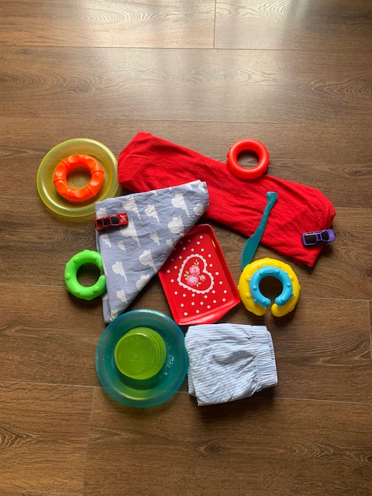

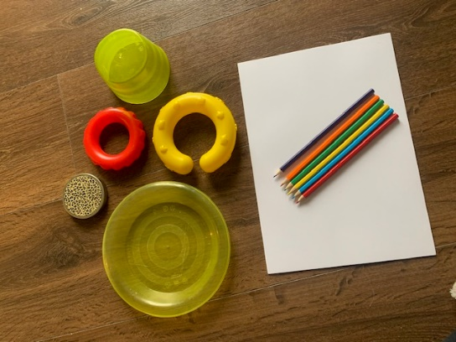
Kandsinksy circles

Find some circular items in different sizes.
Get some plain paper and some coloured pens or pencils.
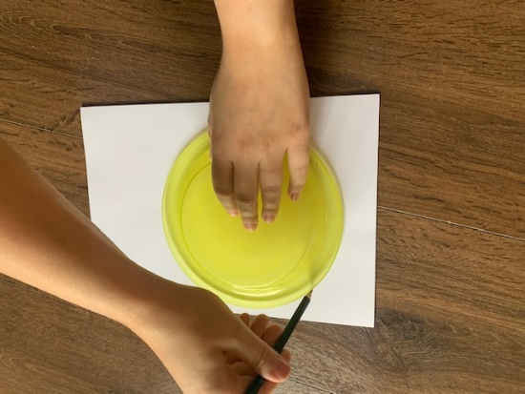
Draw around the items so that you have all different sized circles

Here are Miss Jackson’s examples:
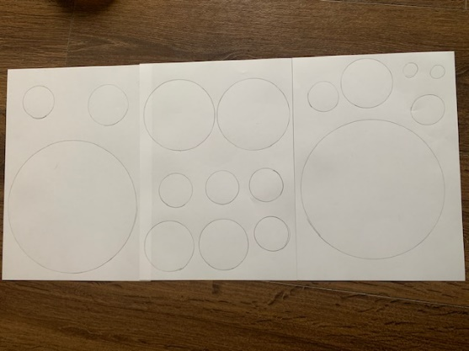

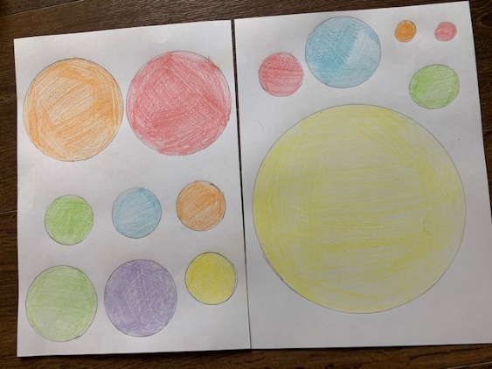
Colour them in using primary and secondary colours.
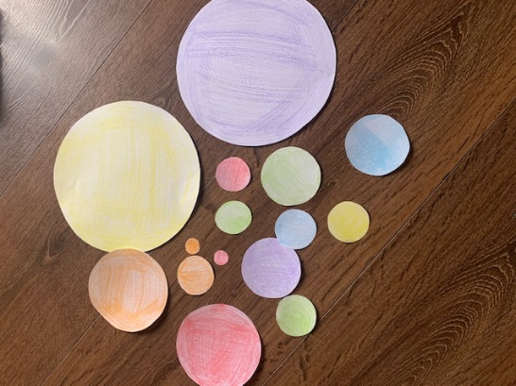
After that, cut them out. Ask an adult before you use the scissors!

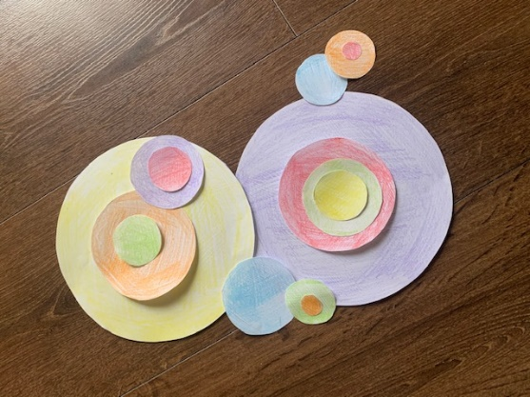
Arrange your circles like Kandinsky did.

