Create a fruit and vegetable face
Study the painting ‘Vertumnus’ by Giuseppe Arcimboldo. Plan your own Arcimboldo inspired fruit and vegetable face using the checklist.

Create with real fruit and then draw and colour your portrait.
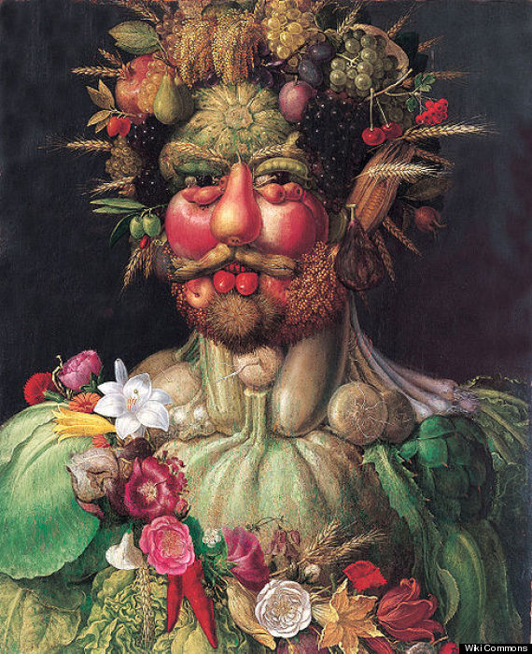

What will you use for the …………………………………………..?
neck
hair
ears
eyes
mouth


