Facts about Giuseppe Arcimboldo
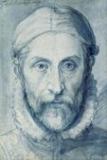
Giuseppe Arcimboldo was born in Milan, Italy on 5th April 1526. He was an Italian painter known for his extraordinary and sometimes monstrous, human portraits. He was inspired by an artist called Leonardo da Vinci through his imaginary figures of humans.

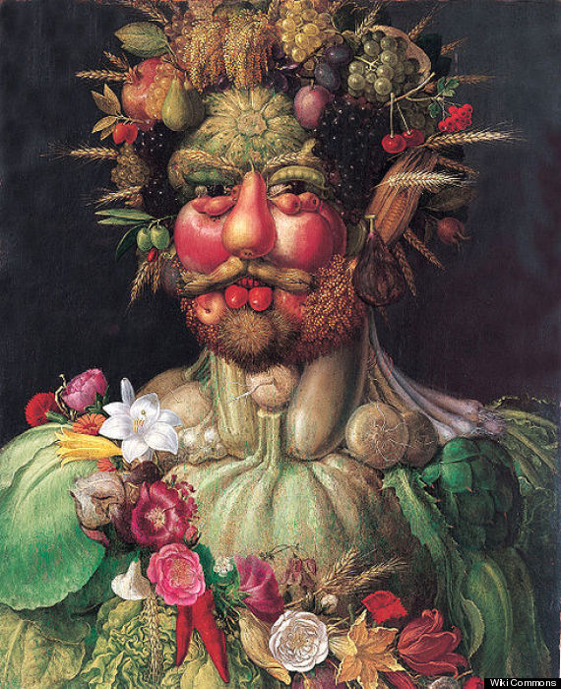
During his life, Giuseppe produces many works of art on religious subjects, but he is most well-known for creating imaginative portrait heads made entirely of objects such as fruits, vegetables, flowers, fish, and books.
In 1566 he painted the ‘Four Seasons’ which is a series of portraits that constructed faces out of blooming blossoms, swollen gourds, withered roots and ripe grain.
The painting on the right is Giuseppe’s most famous work and is a portrait of the Holy Roman Emperor Rudolf 11 re-imagined as Vertumnus, the Roman God of metamorphoses in nature and in life.
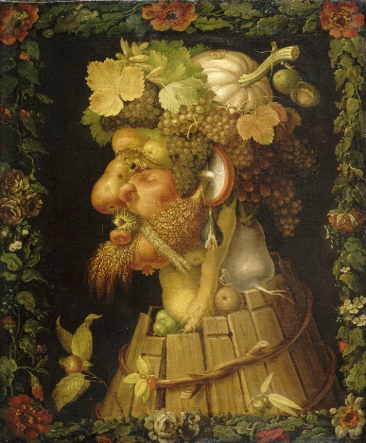
Giuseppe Arcimboldo died on the 11th July 1593 in Milan. Today his work can be seen in several different museums and galleries, including the Louvre in Paris, Uffizi Gallery in Florence and the Denver art museum in Denver, Colorado. His work influenced the work of surrealist painters.

Facts about Giuseppe Arcimboldo
Who is Arcimboldo?
When was he born?
What is he known for?
What is his most famous work?

When did he die?
Other facts

