Giuseppe Arcimboldo
Giuseppe Arcimboldo is an Italian painter who is famous for drawing and painting portraits made entirely of fruit, vegetables, and flowers.
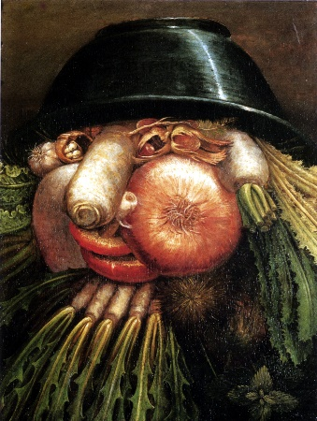
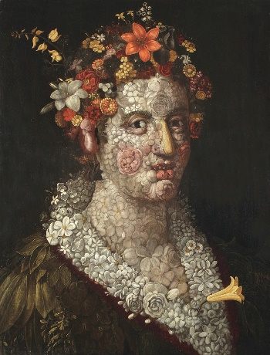
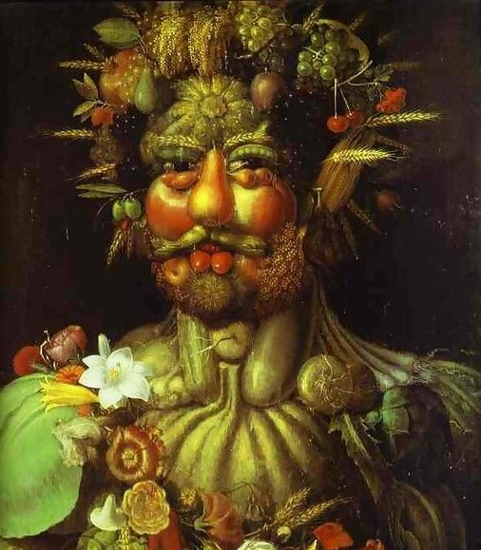
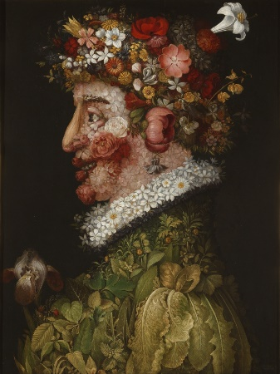
Look at the following paintings by the artist and answer the questions.

What do you like about the paintings? Why?
- - - - - - - - - - - - - - - - - - - - - - - - - - - - - - - - - - - - - - - - - - - - - - - - - - - - - - - - - - - - - - - - - - - - - - - - - - - - - - - - - - - - - - - - - - - - - - - - - - - - - - - - - -__________________________________________________________________________________________________________________________________________________________________________________________________________________________________
- - - - - - - - - - - - - - - - - - - - - - - - - - - - - - - - - - - - - - - - - - - - - - - - - - - - - - - - - - - - - - - - - - - - - - - - - - - - - - - - - - - - - - - - - - - - - - - - - - - - - - - - - - __________________________________________________________________________________________________________________________________________________________________________________________________________________________________
- - - - - - - - - - - - - - - - - - - - - - - - - - - - - - - - - - - - - - - - - - - - - - - - - - - - - - - - - - - - - - - - - - - - - - - - - - - - - - - - - - - - - - - - - - - - - - - - - - - - - - - - - -__________________________________________________________________________________________________________________________________________________________________________________________________________________________________
- - - - - - - - - - - - - - - - - - - - - - - - - - - - - - - - - - - - - - - - - - - - - - - - - - - - - - - - - - - - - - - - - - - - - - - - - - - - - - - - - - - - - - - - - - - - - - - - - - - - - - - - - -

What do you not like about the paintings? Why?
- - - - - - - - - - - - - - - - - - - - - - - - - - - - - - - - - - - - - - - - - - - - - - - - - - - - - - - - - - - - - - - - - - - - - - - - - - - - - - - - - - - - - - - - - - - - - - - - - - - - - - - - - -__________________________________________________________________________________________________________________________________________________________________________________________________________________________________
- - - - - - - - - - - - - - - - - - - - - - - - - - - - - - - - - - - - - - - - - - - - - - - - - - - - - - - - - - - - - - - - - - - - - - - - - - - - - - - - - - - - - - - - - - - - - - - - - - - - - - - - - - __________________________________________________________________________________________________________________________________________________________________________________________________________________________________
- - - - - - - - - - - - - - - - - - - - - - - - - - - - - - - - - - - - - - - - - - - - - - - - - - - - - - - - - - - - - - - - - - - - - - - - - - - - - - - - - - - - - - - - - - - - - - - - - - - - - - - - - -__________________________________________________________________________________________________________________________________________________________________________________________________________________________________
- - - - - - - - - - - - - - - - - - - - - - - - - - - - - - - - - - - - - - - - - - - - - - - - - - - - - - - - - - - - - - - - - - - - - - - - - - - - - - - - - - - - - - - - - - - - - - - - - - - - - - - - - -

