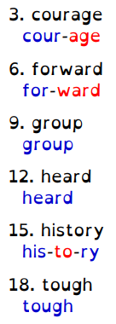
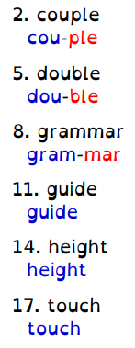
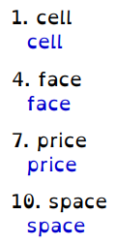
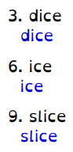
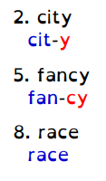
Red Spellings

Green and Blue Spellings
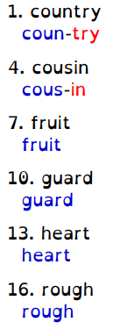
4T Homework

Round 434 to the nearest 1000 and nearest 100.
Round 74 to the nearest 10 and 100.
Complete the missing numbers:
250, 350, ______, 450, _______
10, 5, ______, -5, _________
2, 4, 6, ________, 10, _______
-
There were 1239 people in the supermarket. 304 people left. How many people are now in the supermarket?
There were 67 people in the supermarket. 12 people leave. How many people are now in the supermarket?

On Tuesday I got 350 points on ttrockstars. On Wednesday I got another 1020. How many points did I score in two days?
I have 35 socks. I find 5 more socks under the bed. How many socks do I now have?

Arithmetic Choose Red or Blue

