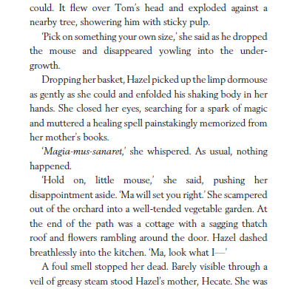
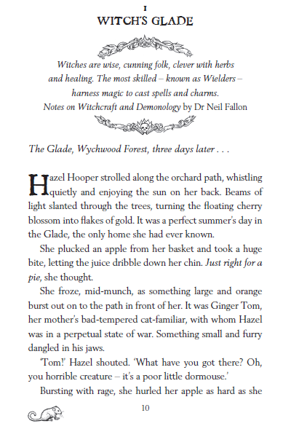
From ‘Fire-Girl’ by Matt Ralphs
Looking Questions
- Where does Hazel Hooper live?
- Find and copy a phrase that shows it is warm in the forest.
- What are the most talented type of witches called?
Clue Questions
- Use evidence from the text to explain how Hazel feels when she sees Ginger Tom.
- Does Hazel find magic easy? Give two reasons for your answer.
- What might be causing the “foul smell”?
Thinking questions
- How does the writer show that Hazel is a caring girl?
- Why do you think the writer chose to start with a quote from another book?
Challenge Question (extended answer)
- What do we know about Hazel and her life? Use quotes from the text to back up your answer.

Write your answers on a piece of paper, take a picture and send to y5@holytrinity.manchester.sch.uk

