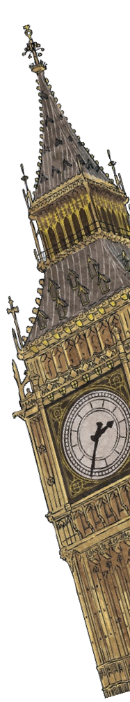
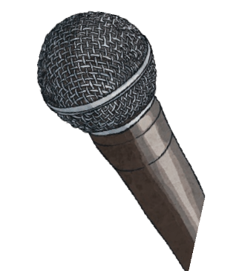
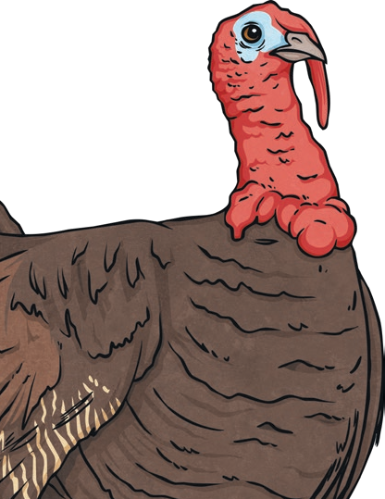
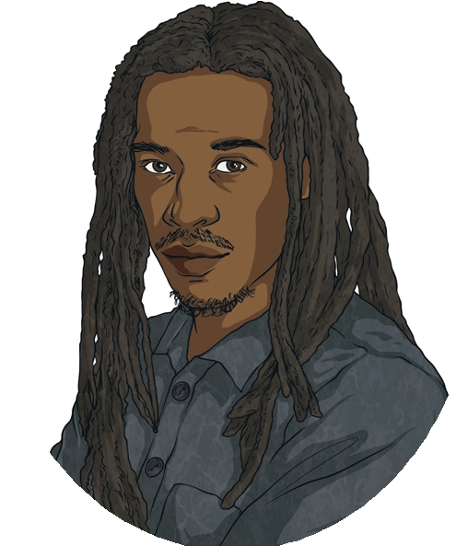
Benjamin Zephaniah
Benjamin Obadiah Iqbal Zephaniah is a British writer. He has written lots of books, poems and plays for children and adults. His first book of poetry for children, Talking Turkeys, was so popular that it
sold out in only six weeks!

Early Life
Benjamin Zephaniah was born on the 15th April 1958 in Birmingham. His father was a postal worker and his mother was a nurse. He left school when he was 13 years old. At this time, he started writing and performing poetry. His
poems were based on events that he saw happening both locally and around the world.

Moving to London
Benjamin did not like the idea that poetry was only for people who were still in school or at university. He thought that poetry should be something that everybody could enjoy. Because of this, he began performing his poems in a style called dub poetry. Dub poetry does not use musical instruments; instead, the poet reads with rhythm and changes the pitch of their voice to make the poem sound musical. Benjamin performed poetry for the first time when he was just 10 years old. By the time he was 15 years old, he was well known for his poetry around his home town. However, Benjamin wanted a bigger audience to hear his poems so he moved to London when he was 22 years old. This was where he had his first book of poetry published.

Books and Poetry
Benjamin has written lots of different books, poems and plays. To begin with, he did not want to write a book aimed just at children. This is because he believed that poetry shouldn’t be given an age limit. In 1999, Benjamin published his first fictional book
for teenagers.

Causes

Benjamin Zephaniah

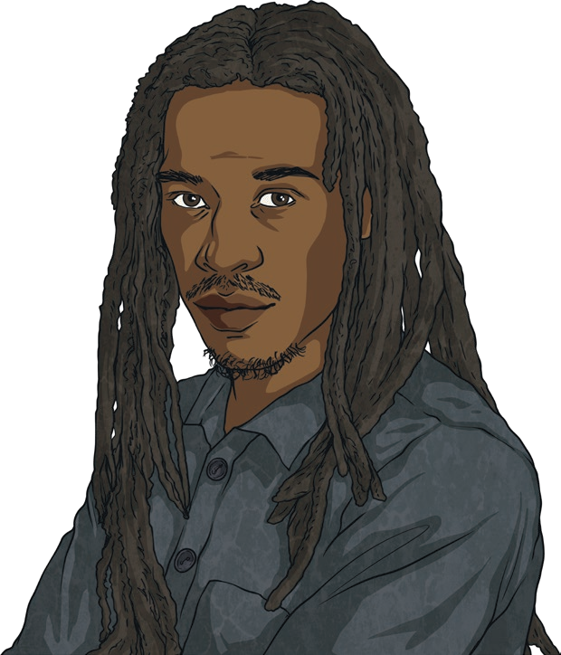
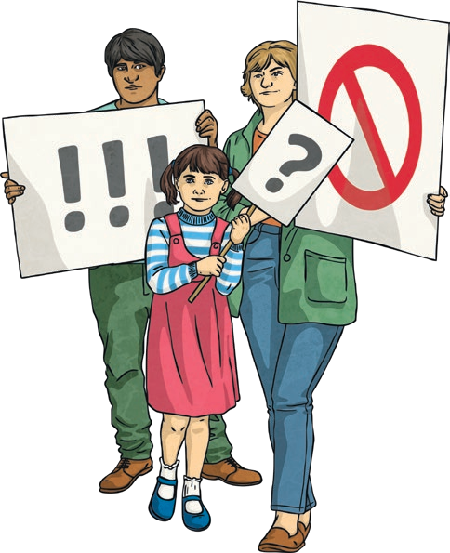
When creating poems, Benjamin writes about things that
he has strong beliefs about. In the early 1980s, he created poetry which argued against issues he saw in Britain. During this time, his poems were performed at protests and outside police stations.
Benjamin still supports a number of animal rights groups and human rights groups, using their messages to create even more poetry.

Achievements
During his time as an author and poet, Benjamin
has won lots of awards. In 2009, one poll named
him as the nation’s third favourite poet. He was the only
living poet to make it into the top ten! So far, 16 universities have awarded him with an honorary doctorate. This means that he is a doctor of letters, literature and arts. It also means that he can use a title before his name, making him Dr Benjamin Zephaniah. In 2008, Benjamin won an award for creating the best original song; this shows that he is a successful musician as well as a poet.
Benjamin is still writing poetry and creating music to this day. He spends most of his time at his home in China although he still likes to travel to different countries. Many young writers and singers say that they have been inspired by Benjamin because he writes music and poetry that everyone can enjoy.

